**Exploratory Analysis**

## **Basic Statistical Analysis and Data Cleaning Insights:**

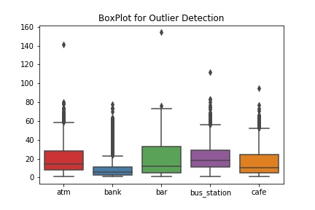

Figure 1-1: Outlier Detection using Box Plot

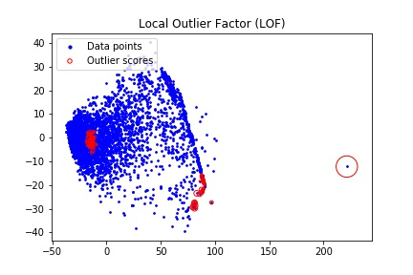

Figure 1-2: Outlier Detection using LOF



Figure 1-3: Isolation Forest Outlier Detection

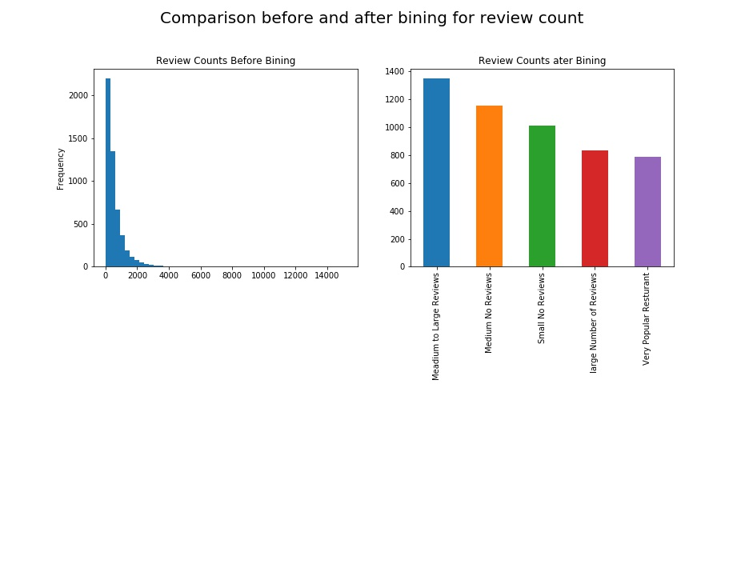

Figure 1-4: Data Binning Example

### 

### Additional Feature Engineering

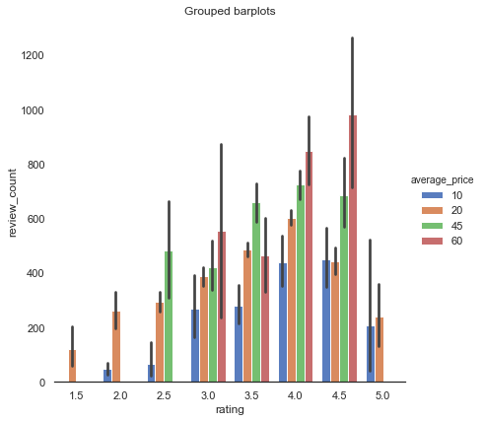

Figure 2-1: Grouped bar plots for rating vs review counts grouped by average price

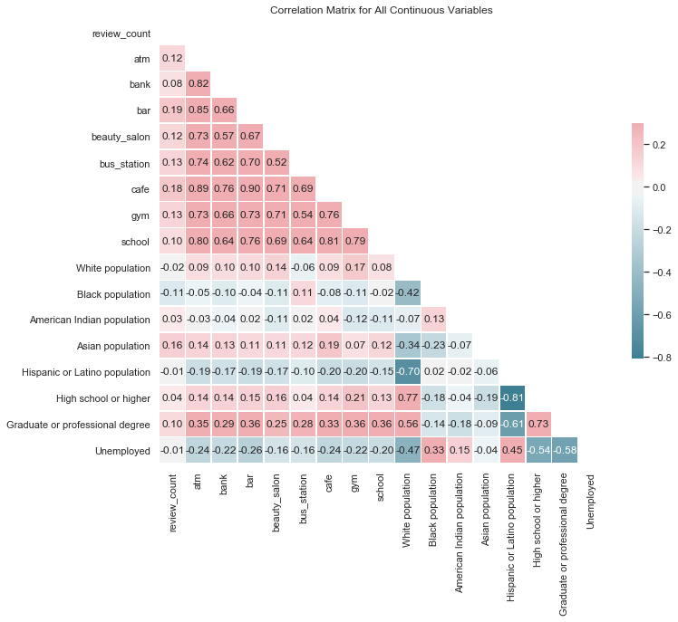

Figure 2-2: Correlation Matrix for Continuous Variables

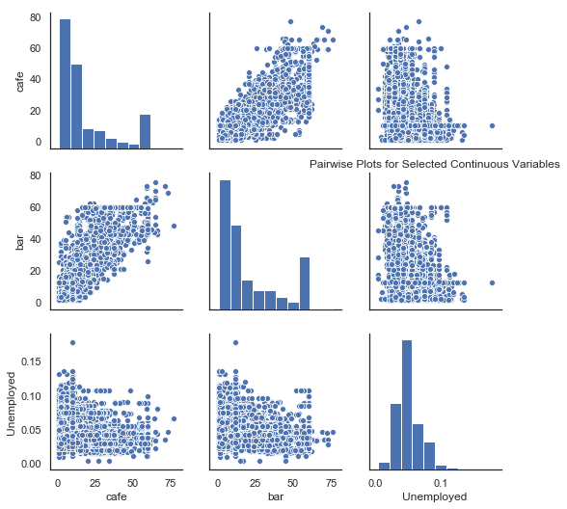

Figure 2-3: Pairwise Plot for three selected Continuous Variables

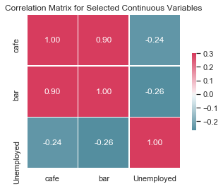

Figure 2-4: Correlation Matrix for three selected Continuous Variables

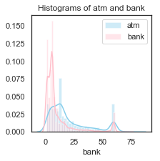

Figure 2-5: Histogram of atm and bank

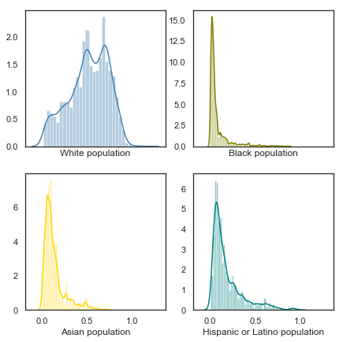

Figure 2-6: Histograms of four races

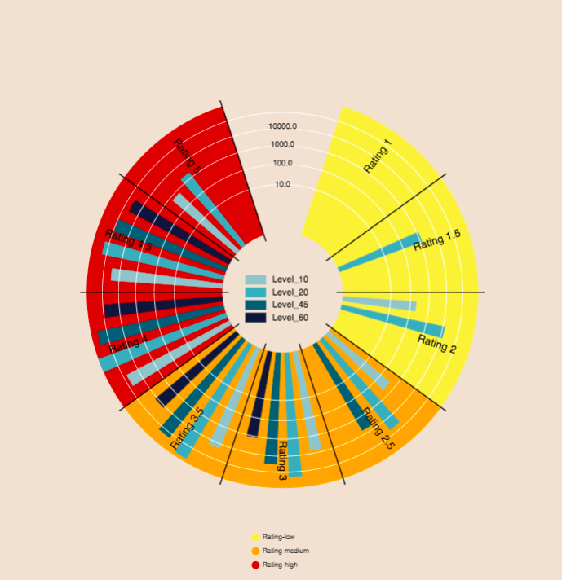

Figure 2-7: Pie for rating vs review counts grouped by average price

**Cluster Analysis**

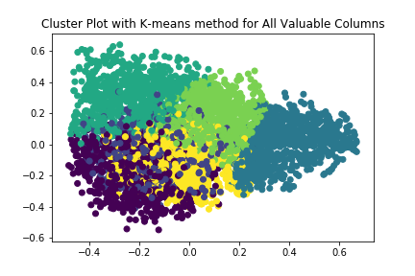

Figure 3-1: 2D graph for k-means method for All Valuable Columns with n=6

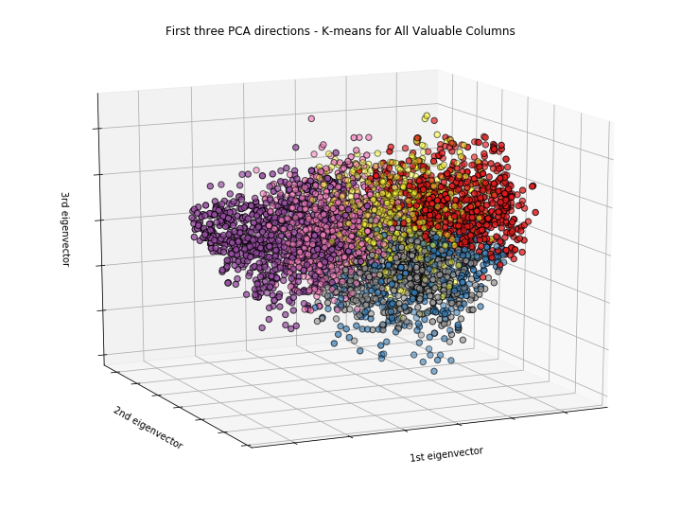

Figure 3-2: 3D graph for k-means method for All Valuable Columns with n=6

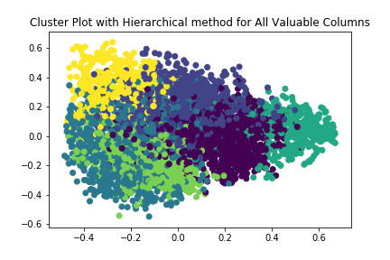

Figure 3-3: 2D graph for hierarchical method for All Valuable Columns with n=6

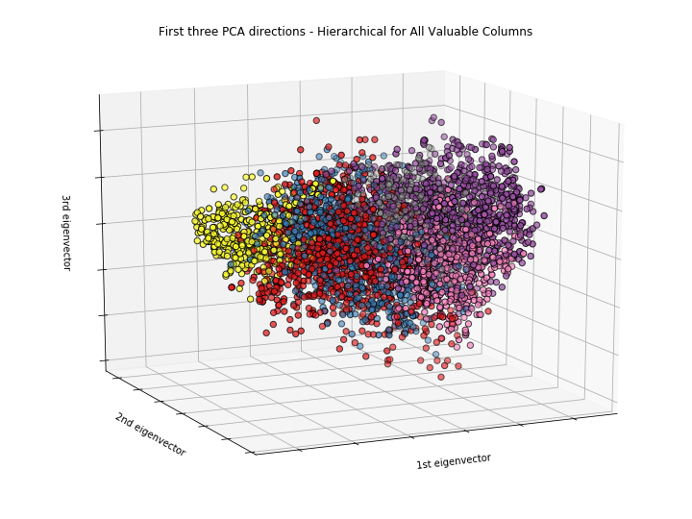

Figure 3-4: 3D graph for hierarchical method for All Valuable Columns with n=6

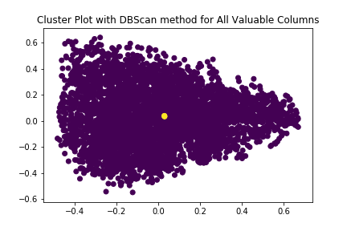

Figure 3-5: 2D graph for dbscan method for All Valuable Columns

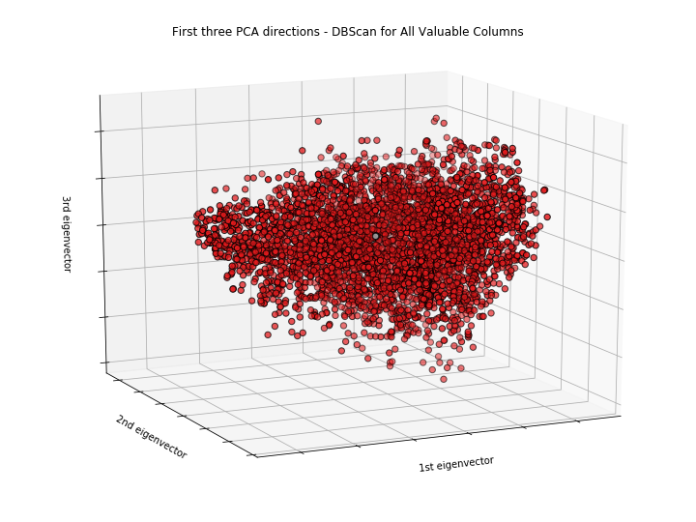

Figure 3-6: 3D graph for dbscan method for All Valuable Columns

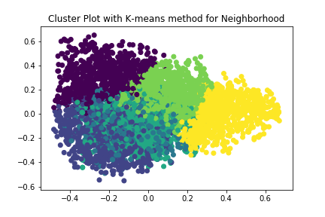

Figure 3-7: 2D graph for k-means method for Neighbourhood with n=6

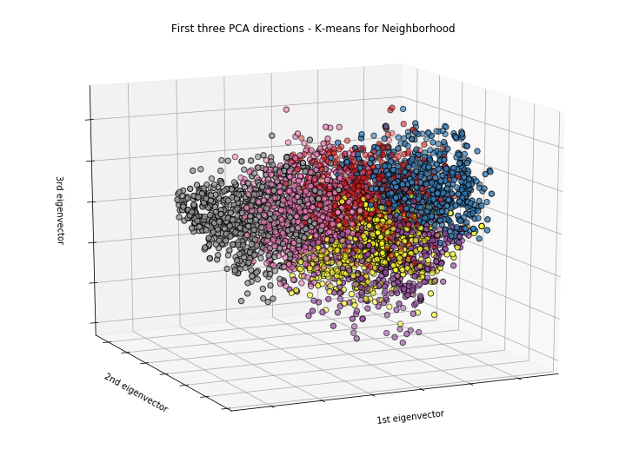

Figure 3-8: 3D graph for k-means method for Neighbourhood with n=6

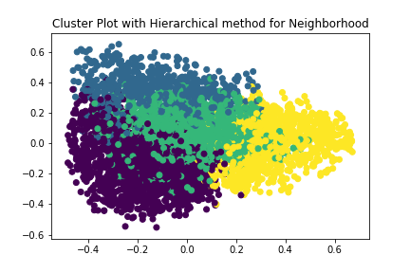

Figure 3-9: 2D graph for hierarchical method for Neighbourhood with n=4

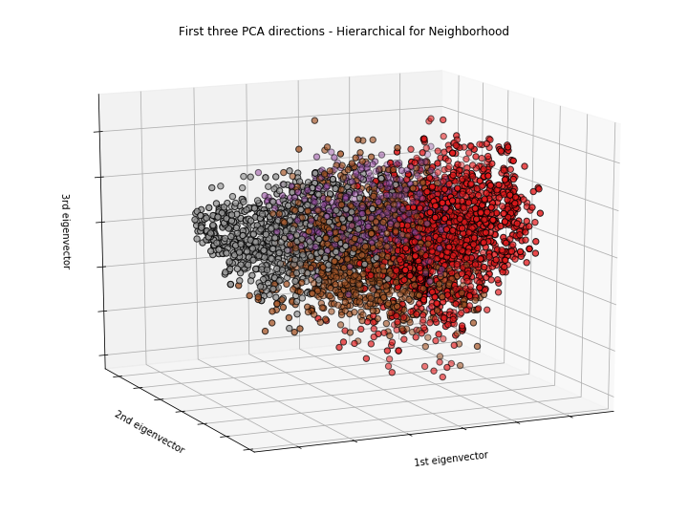

Figure 3-10: 3D graph for hierarchical method for Neighbourhood with n=4

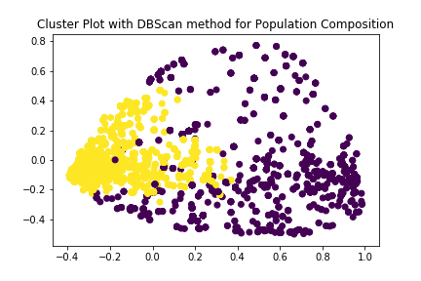

Figure 3-11: 2D graph for dbscan method for Neighbourhood

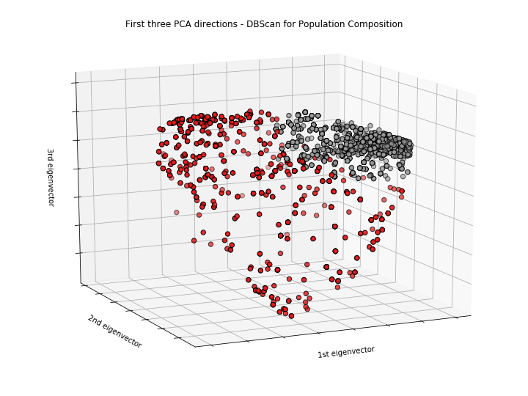

Figure 3-12: 3D graph for dbscan method for Neighbourhood

**Association Rules / Frequent Itemset Mining Analysis**

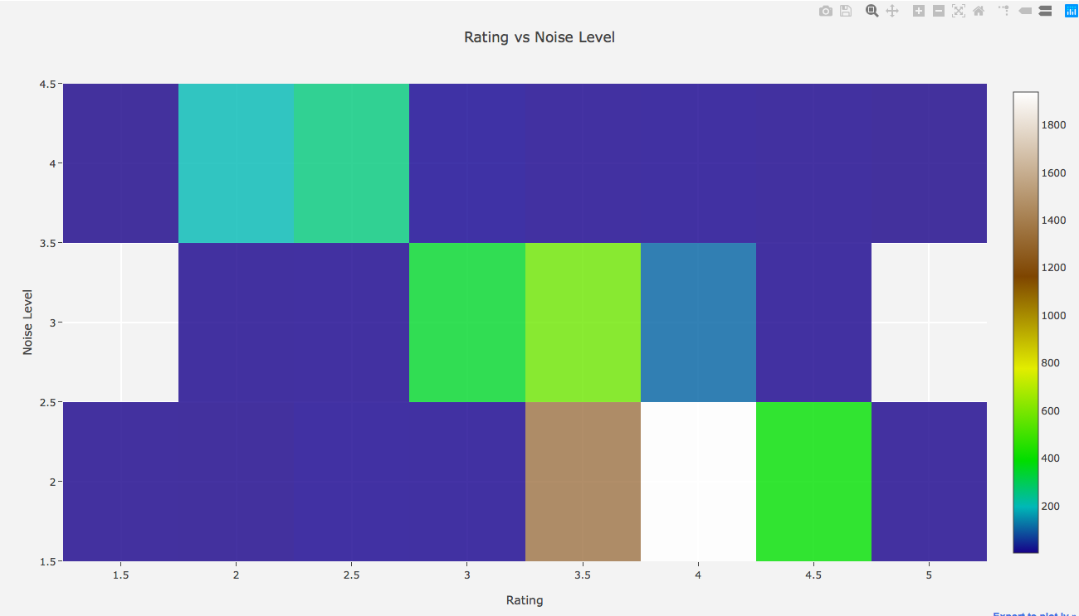

Figure 4-1: Heatmap For Noise Level and Rating

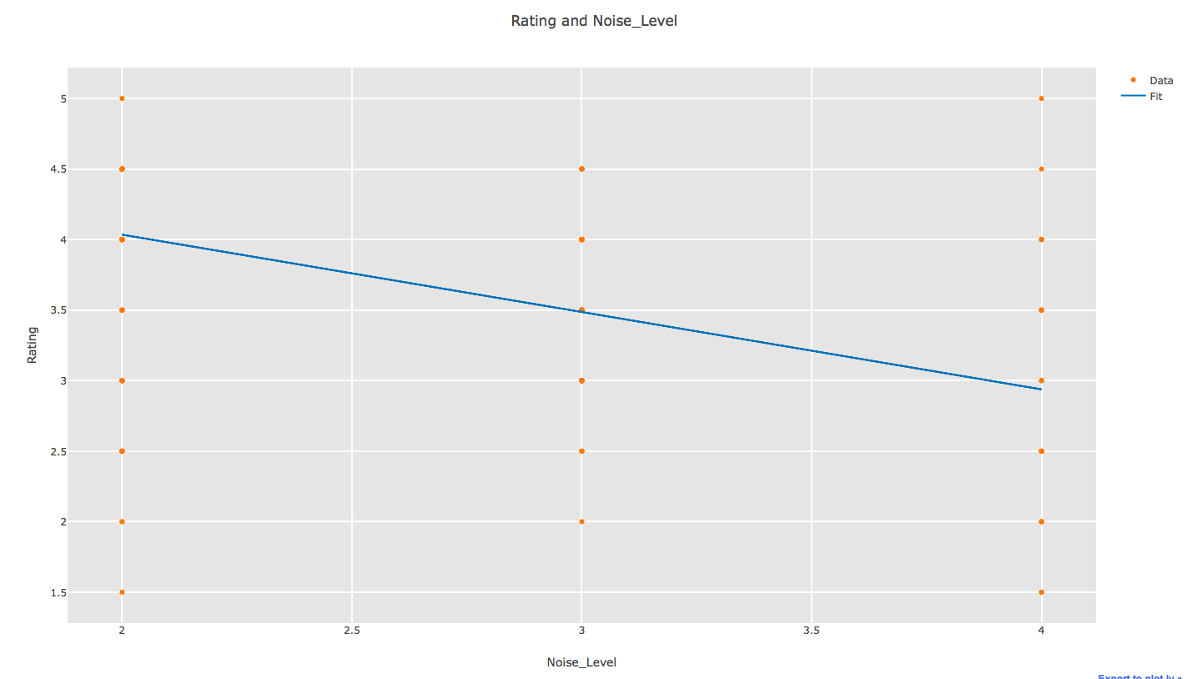

Figure 4-2: Linear Regression Graph For Noise Level and Rating

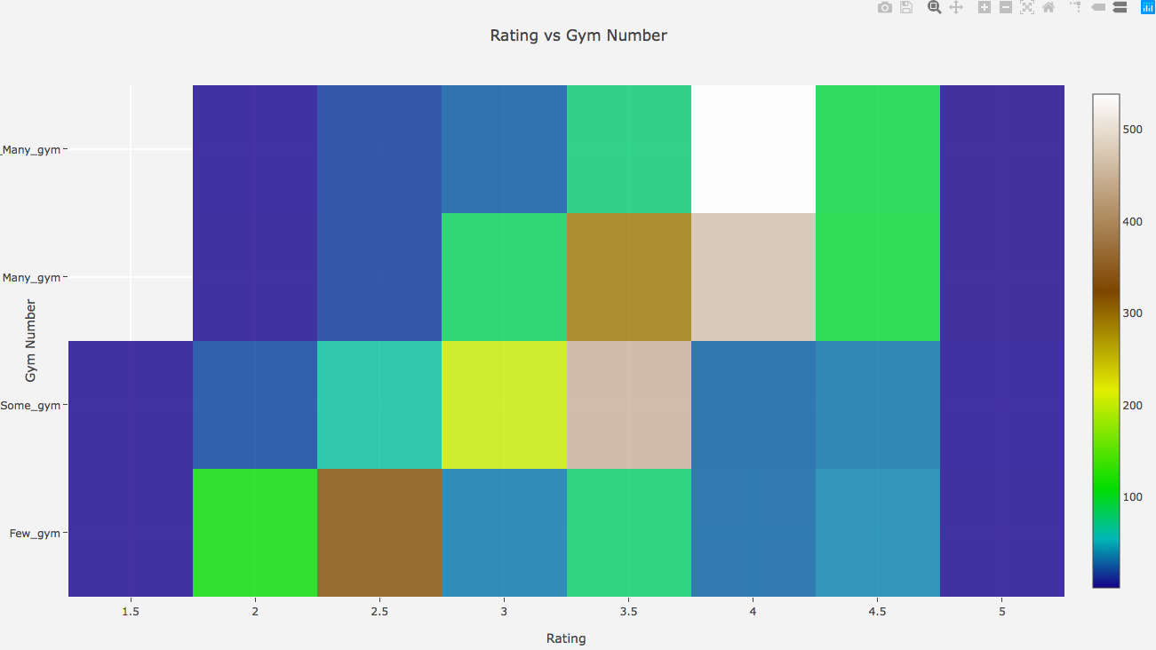

Figure 4-3: Heatmap For Gym Number and Rating

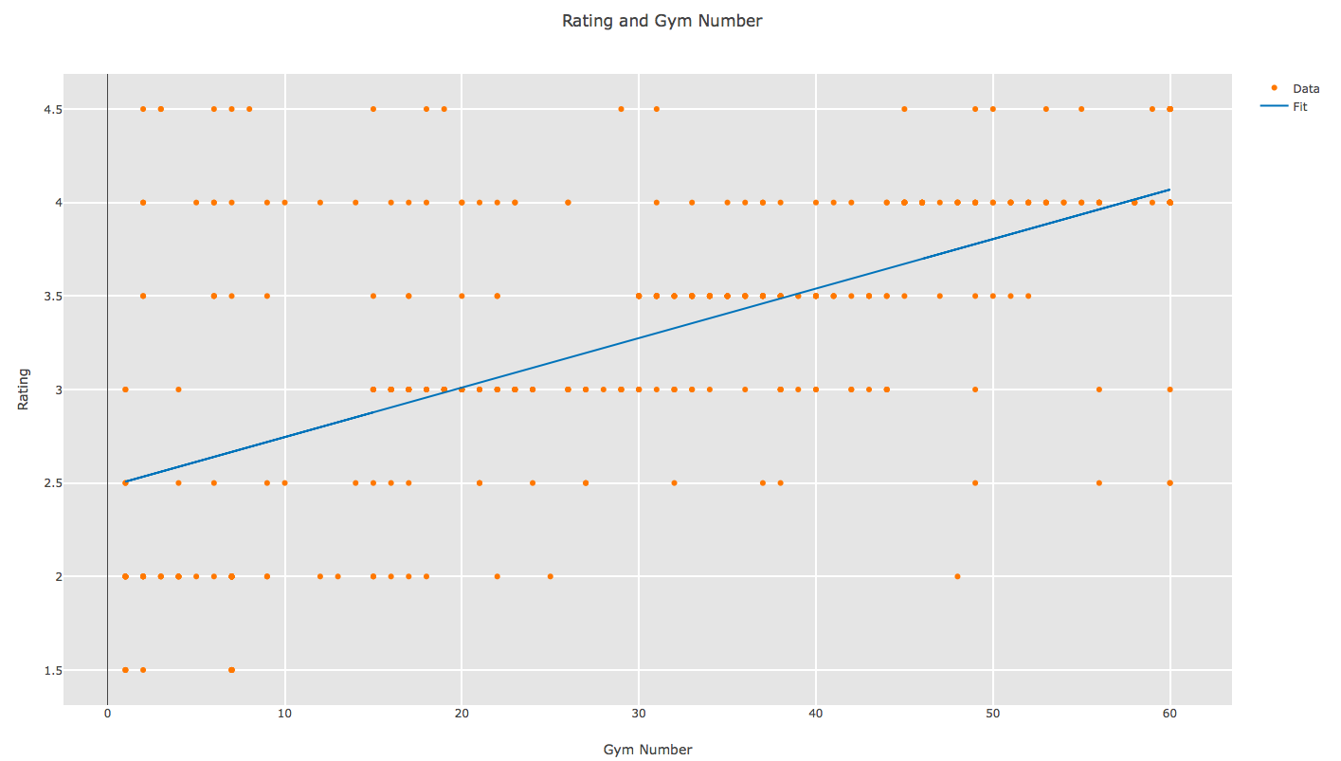

Figure 4-4: Linear Regression Graph For Gym Number and Rating

**Predictive Analysis**

**Hypothesis Generation and Proposed Methods**

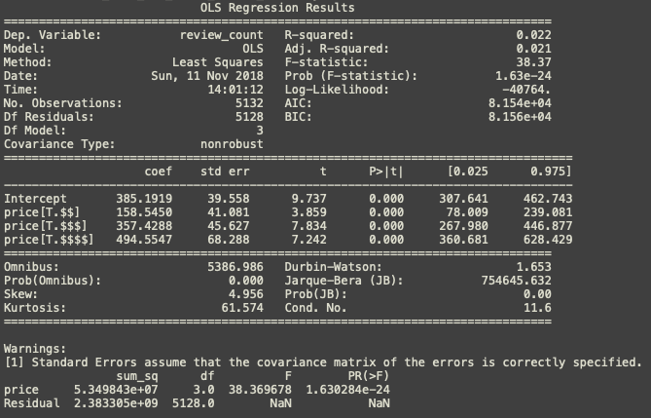

Figure 5-1: ANOVA Test Result



Figure 5-2: ANOVA Q-Q Plot

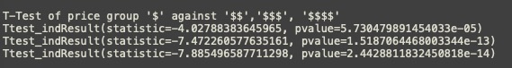

Figure 5-3: Pair-wise T-test Example



Figure 5-4: Linear regression Model Result

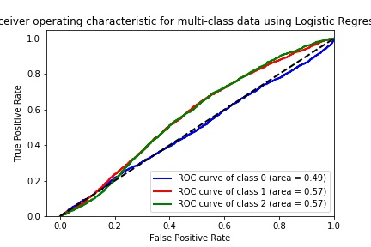

Figure 5-5: ROC for Logistic Regression

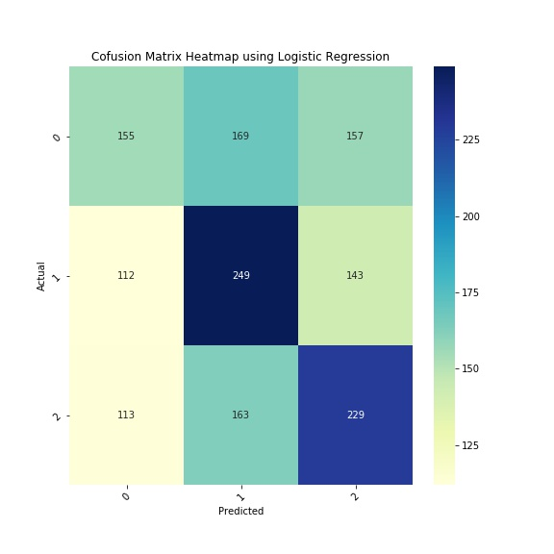

Figure 5-6: Confusion Matrix Heatmap for Logistic Regression

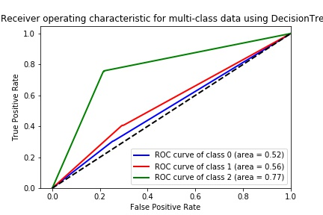

Figure 5-7: ROC Curve for Decision Tree



Figure 5-8: Confusion Matrix Heatmap for Decision Tree

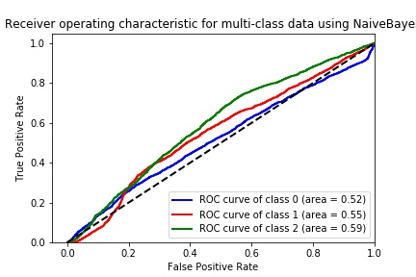

Figure 5-9: ROC curve for Naive Bayes Classifier

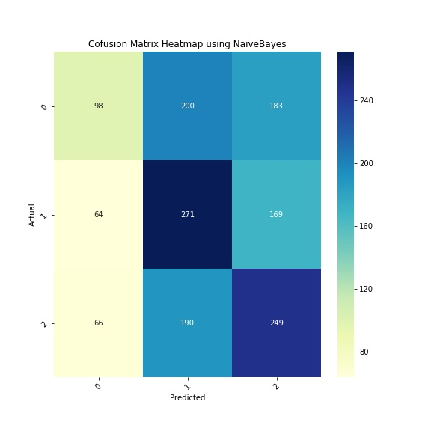

Figure 5-10: Confusion Matrix Heatmap of Naive Bayes

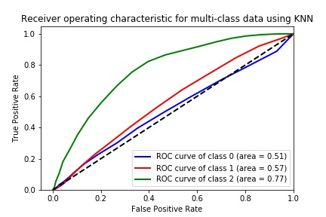

*Figure 5-11: ROC for KNN*

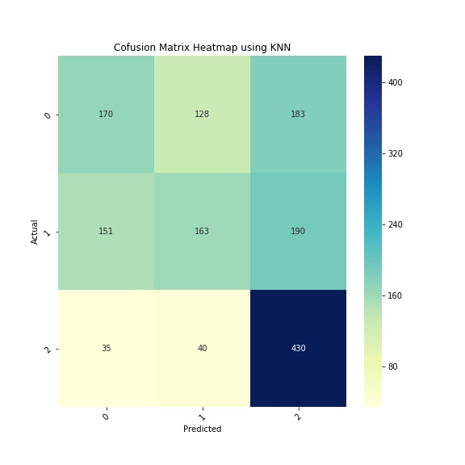

*Figure 5-12: Confusion Matrix Heatmap for KNN*

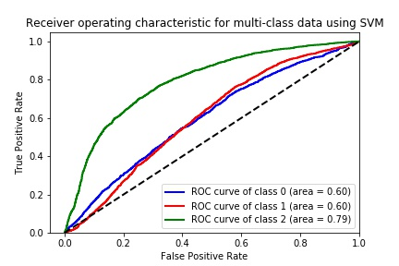

Figure 5-13: ROC for SVM

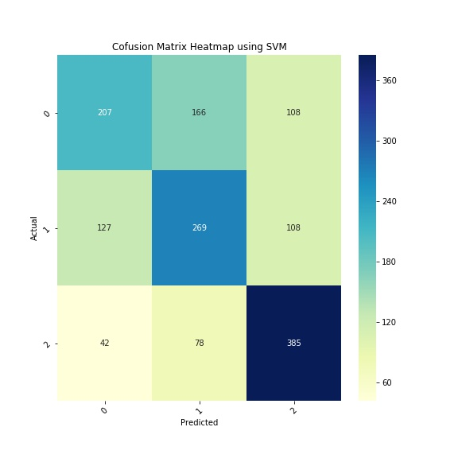

Figure 5-14: Confusion Matrix Heatmap for SVM

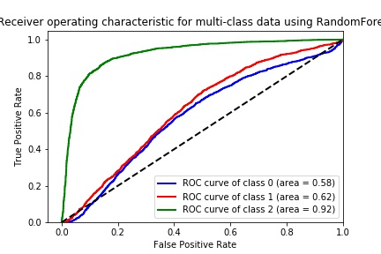

Figure 5-15: ROC for random Forest

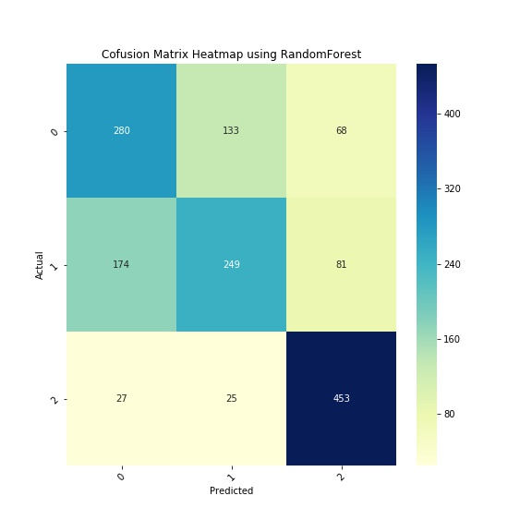

Figure 5-16: Confusion Matrix Heatmap for Random Forest

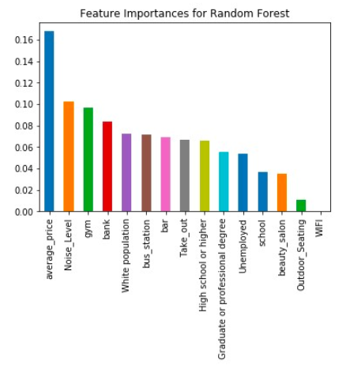

Figure 5-17: Feature Importances for Random Forest

**Additional Analysis:**

## **Review Data Exploratory Analysis:**

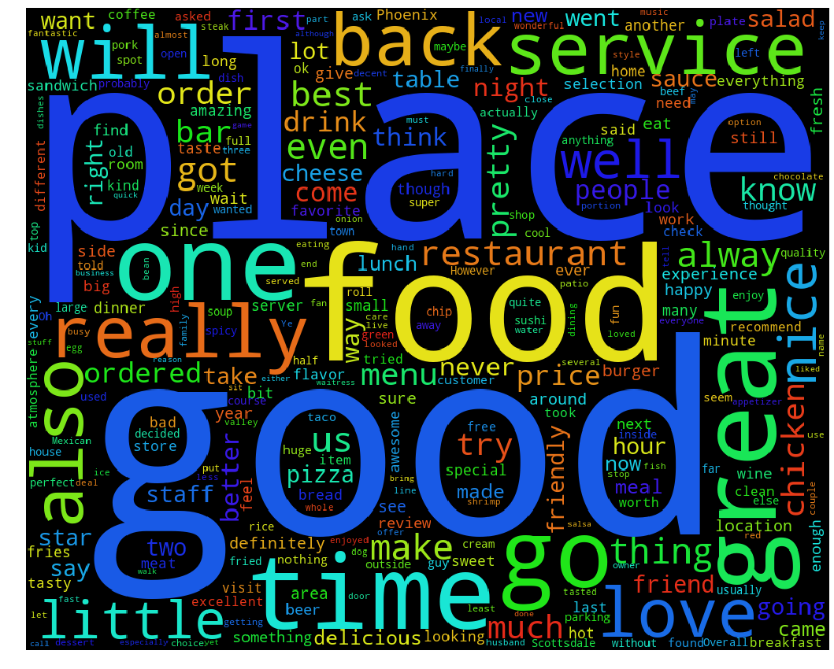

Figure 6-1: Word cloud and Density plot

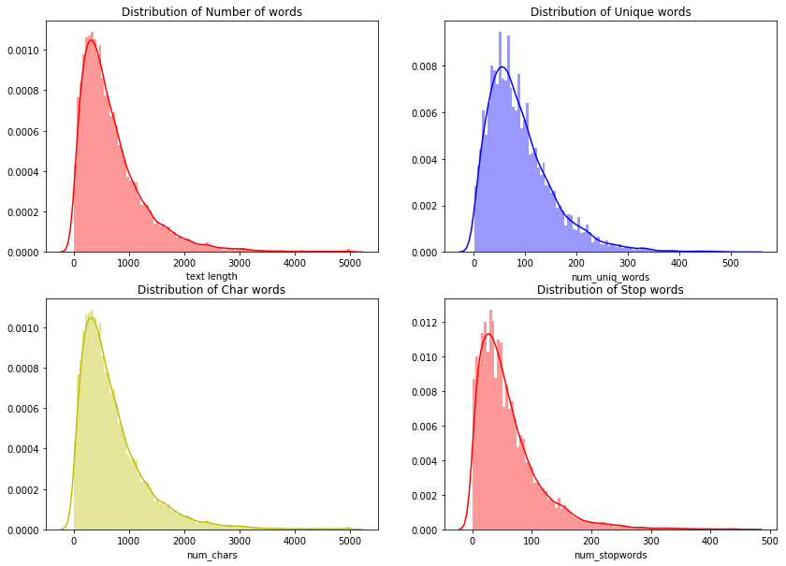

*Figure 6-2: Histogram Of words*



*Figure 6-3: Heat Map of confusion matrix*

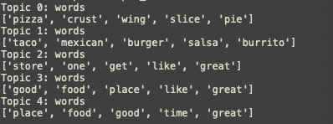

##### *Figure 6-4: Output top words*



*Figure 6-5: Bar plot of comparison*